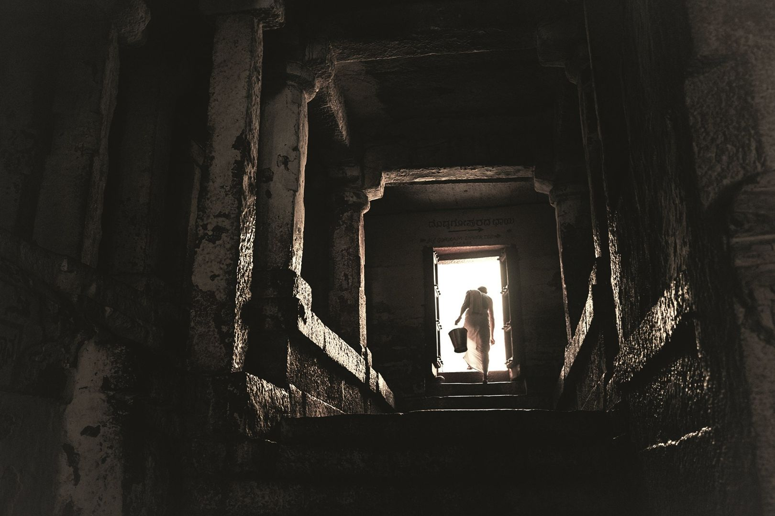VIRUPAKSHA TEMPLE

**MOHAMMED HASHIM PT**

**LOVELY PROFESSIONAL UNIVERSITY**

**REG NO:11611023**

**SECTION:A1604**

**ROLL NO:A08**

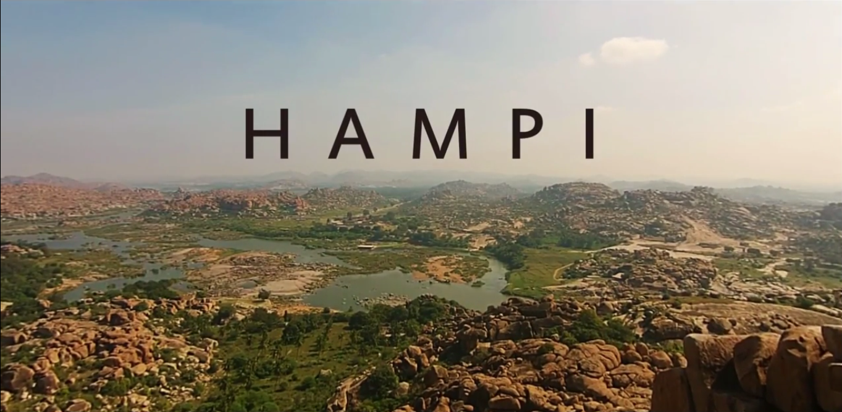

The toponym *Hampi*—traditionally known as *Pampa-kshetra*, *Kishkindha-kshetra* or *Bhaskara-kshetra*—is derived from Pampa, another name of goddess [Parvati](https://en.wikipedia.org/wiki/Parvati) in Hindu theology. According to mythology, the maiden Parvati resolves to marry the loner ascetic [Shiva](https://en.wikipedia.org/wiki/Shiva). Her parents learn of her desire and discourage her, but she pursues her desire. Shiva is lost in yogic meditation, oblivious to the world; Parvati appeals to the gods for help to awaken him and gain his attention. Indra sends the god [Kama](https://en.wikipedia.org/wiki/Kamadeva)—the Hindu god of desire, erotic love, attraction and affection—to awake Shiva from meditation. Kama reaches Shiva and shoots an arrow of desire. Shiva opens his third eye in his forehead and burns Kama to ashes. Parvati does not lose her hope or her resolve to win over Shiva; she begins to live like him and engage in the same activities—asceticism, [yogin](https://en.wikipedia.org/wiki/Yogi) and [tapasya](https://en.wikipedia.org/wiki/Tapas_(Sanskrit))—awakening him and attracting his interest. Shiva meets Parvati in disguised form and tries to discourage her, telling her Shiva's weaknesses and personality problems. Parvati refuses to listen and insists in her resolve. Shiva finally accepts her and they get married.According to [*Sthala Purana*](https://en.wikipedia.org/wiki/Sthala_Purana), Parvati (Pampa) pursued her ascetic, yogini lifestyle on Hemakuta Hill, now a part of Hampi, to win and bring ascetic Shiva back into householder life.Shiva is also called Pampapati (lit. "husband of Pampa").The river near the Hemkuta Hill came to be known as Pampa river.The Sanskrit word Pampa morphed into the [Kannada](https://en.wikipedia.org/wiki/Kannada) word Hampa and the place Parvati pursued Shiva came to be known as Hampe or Hampi. Hampi, also referred to as the Group of Monuments at Hampi, is a [UNESCO](https://en.wikipedia.org/wiki/UNESCO) [World Heritage Site](https://en.wikipedia.org/wiki/World_Heritage_Site) located in east-central [Karnataka](https://en.wikipedia.org/wiki/Karnataka), India. It became the centre of the Hindu [Vijayanagara Empire](https://en.wikipedia.org/wiki/Vijayanagara_Empire) capital in the 14th century. Chronicles left by Persian and European travellers, particularly the Portuguese, state Hampi was a prosperous, wealthy and grand city near the [Tungabhadra River](https://en.wikipedia.org/wiki/Tungabhadra_River), with numerous temples, farms and trading markets. By 1500 CE, Hampi-Vijayanagara was the world's second-largest medieval-era city after [Beijing](https://en.wikipedia.org/wiki/Beijing), and probably India's richest at that time, attracting traders from Persia and Portugal. The Vijayanagara Empire was defeated by a coalition of Muslim sultanates; its capital was conquered, pillaged and destroyed by sultanate armies in 1565, after which Hampi remained in ruins.

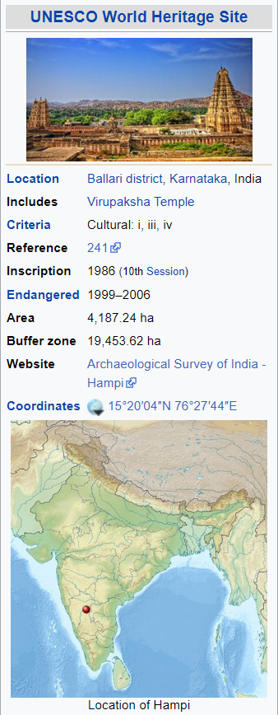**VIRUPAKSHA TEMPLE**

**History**

The temple's history is uninterrupted from about the 7th century. The Virupaksha-Pampa sanctuary existed well before the Vijayanagara capital was located here. Inscriptions referring to Shiva date back to the 9th and 10th centuries.] What started as a small shrine grew into a large complex under the [Vijayanagara](https://en.wikipedia.org/wiki/Vijayanagara) rulers. Evidence indicates there were additions made to the temple in the late [Chalukyan](https://en.wikipedia.org/wiki/Chalukyan) and [Hoysala](https://en.wikipedia.org/wiki/Hoysala) periods, though most of the temple buildings are attributed to the Vijayanagar period. The huge temple building was built by Lakkana Dandesha, a chieftain under the ruler [Deva Raya II](https://en.wikipedia.org/wiki/Deva_Raya_II) of the [Vijayanagara Empire](https://en.wikipedia.org/wiki/Vijayanagara_Empire).

Under the Vijayanagara rulers, in the middle of the 14th century, there began a flowering of native art and culture. When the rulers were defeated by Muslim invaders in the 16th century, most of the wonderful decorative structures and creations were systematically destroyed.

The religious sect of Virupaksha-Pampa did not end with the destruction of the city in 1565. Worship there has persisted throughout the years. At the beginning of the 19th century there were major renovations and additions, which included ceiling paintings and the towers of the north and east gopura.

Virupaksha Temple is located in [Hampi](https://en.wikipedia.org/wiki/Hampi) 350 km from [Bangalore](https://en.wikipedia.org/wiki/Bangalore), in the state of [Karnataka](https://en.wikipedia.org/wiki/Karnataka) in [southern India](https://en.wikipedia.org/wiki/Southern_India). It is part of the Group of Monuments at Hampi, designated a [UNESCO](https://en.wikipedia.org/wiki/UNESCO) [World Heritage Site](https://en.wikipedia.org/wiki/List_of_UNESCO_World_Heritage_Sites_in_India). The temple is dedicated to Virupaksha, a form of [Shiva](https://en.wikipedia.org/wiki/Shiva). The temple was built by Lakkan Dandesha, a nayaka (chieftain) under the ruler [Deva Raya II](https://en.wikipedia.org/wiki/Deva_Raya_II) of the [Vijayanagara Empire](https://en.wikipedia.org/wiki/Vijayanagara_Empire).

Hampi, capital of the [Vijayanagara empire](https://en.wikipedia.org/wiki/Vijayanagara_empire), sits on the banks of the [Tungabhadra River](https://en.wikipedia.org/wiki/Tungabhadra_River). Virupaksha Temple is the main center of pilgrimage at Hampi, and had been considered the most sacred sanctuary over the centuries. It is intact among the surrounding ruins and is still used in worship . The temple is dedicated to Lord [Shiva](https://en.wikipedia.org/wiki/Shiva), known here as Virupaksha, as the consort of the local goddess Pampadevi who is associated with the Tungabhadra River.

**Temple Structure**

At present, the main temple consists of a sanctum, three ante chambers, a pillared hall and an open pillared hall.It is decorated with delicately carved pillars. A pillared [cloister](https://en.wikipedia.org/wiki/Cloister), entrance gateways, courtyards, smaller shrines and other structures surround the temple

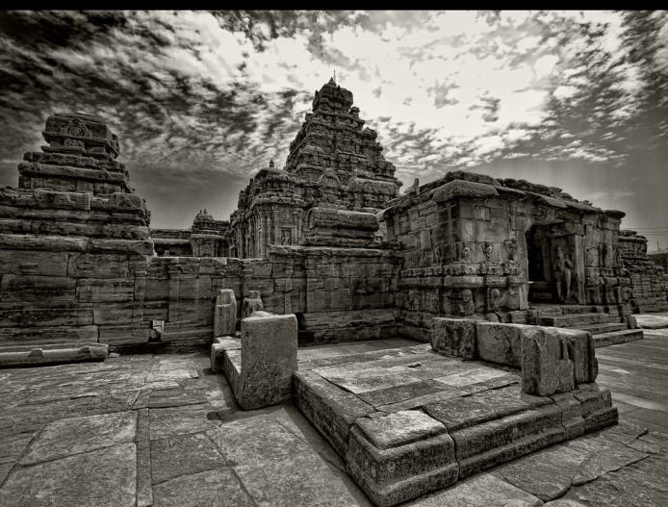The nine-tiered eastern gateway, which is the largest at 50 meters, is well-proportioned and incorporates some earlier structures. It has a brick superstructure and a stone base. It gives access to the outer court containing many sub-shrines. The smaller eastern gateway leads to the inner court with its numerous smaller shrines.Another [*gopuram*](https://en.wikipedia.org/wiki/Gopuram) towards north known as the Kanakagiri *gopura*, leads to a small enclosure with subsidiary [shrines](https://en.wikipedia.org/wiki/Shrine) and eventually to the river [Tungabhadra](https://en.wikipedia.org/wiki/Tungabhadra_River).

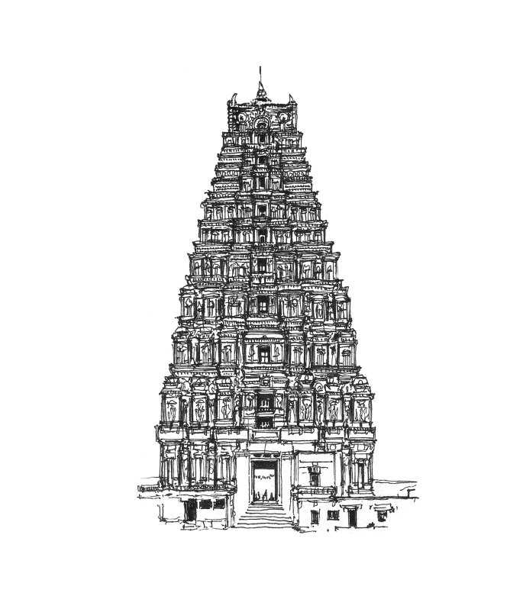A narrow channel of the [Tungabhadra River](https://en.wikipedia.org/wiki/Tungabhadra_River) flows along the temple's terrace and then descends to the temple-kitchen and out through the outer court.

[Krishnadevaraya](https://en.wikipedia.org/wiki/Krishnadevaraya), one of the famous kings of the Vijayanagara Empire was a major patron of this temple. The most ornate of all structures in the temple, the central pillared hall is believed to be his addition to this temple. Inscriptions on a stone plaque installed next to the pillared hall explain his contribution to the temple. It is recorded that Krishna Devaraya commissioned this hall in 1510 AD to mark his accession. These additions meant that the central shrine came to occupy a relatively small part of the complex.The halls in the temple were used for a variety of purposes. Some were spaces in which the images of gods were placed to witness special programmes of music, dance, drama, etc. Others were used to celebrate the marriages of deities.

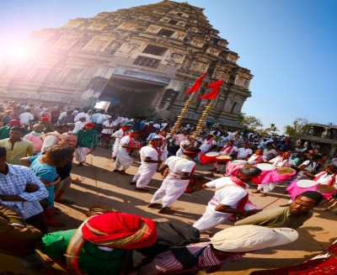**Festivals**

The temple continues to prosper and attracts huge crowds for the betrothal and marriage festivities of Virupaksha and Pampa in December.In the month of February the annual [chariot](https://en.wikipedia.org/wiki/Temple_car) festival is celebrated here.

**Plan of Virupaksha Temple**

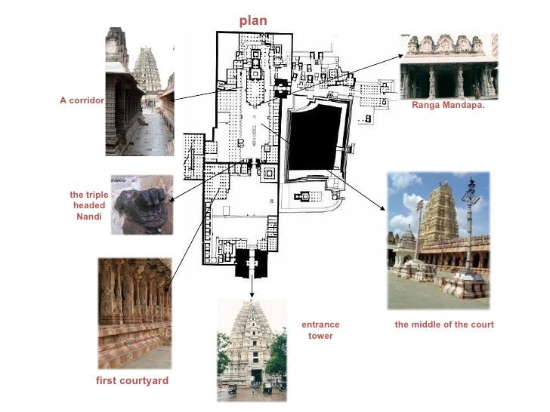

* The most of the square structures are shrines
* The two major gateways are shaded in black
* Each tiny dot represent a pillar
* Rows of pillars arranged in lines with a square or rectangular frame appear to demarcate major halls, pavilion and corridors

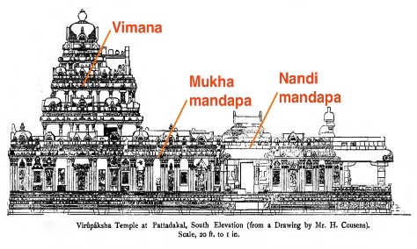**Elevation of Virupaksha Temple**

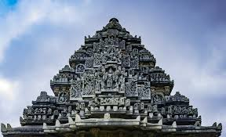**Vimana**:

It is a word with several meanings ranging from temple or palace to mythological flying machines described in Sanskrit epics. References to these flying machines are commonplace in ancient Indian texts, even describing their use in warfare

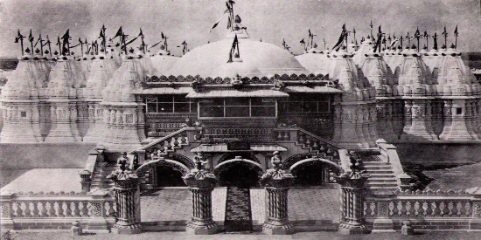**Mukhamaṇḍapa: source; Virupaksha temple**

It is a small pavilion or porch constructed in front of the doorway of the temple. As this the part of the façade of the temple, this pavilion is called by the name mukhamaṇḍapa

**source; Virupaksha temple** 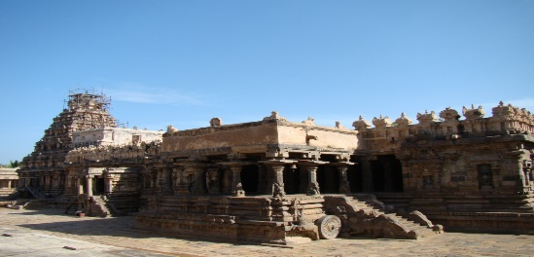

***N*andimaṇḍapas:**

It is always open pavilions. The canopy of the pavilion is erected over four pillars placed at the four comers of the plinth (adhiṣṭhāna). These pillars are decorated according to the order and style of the pillars of the period.

**Raṅgamaṇḍapa: source; Virupaksha temple**

It is a pavilion, which contains a centre stage

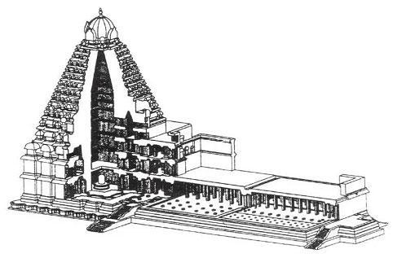**Section of Virupaksha Temple**

**Source; Google pics**

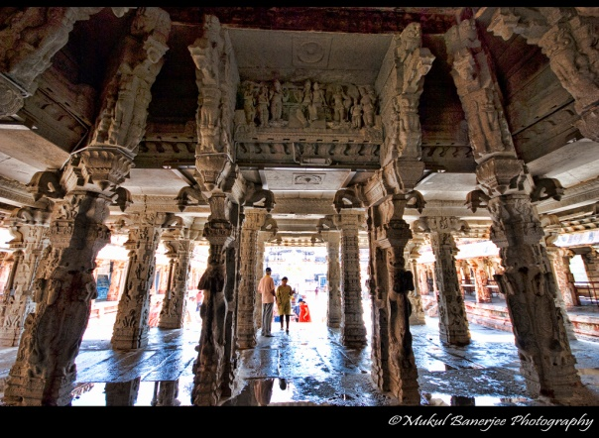**Interior of Virupakasha Temple**

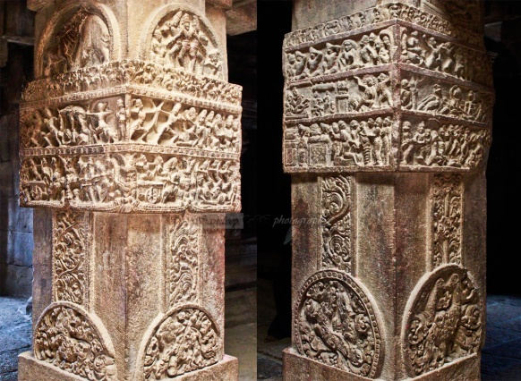

Source; Indian wounderlands

The whole of the interior of this temple is embellished with elegant carvings and aesthetically modeled sculptures. Episodes from the Ramayana (e.g. abduction of Sita) *Mahabharata* (e.g. Bhishma lying in a bed of arrows), *Bhagavata* (e.g. Krishna lifting the Govardhan mountain) and *Kiratarjuniya* (e.g. Arjuna receiving the Pasupatastra from Siva) are depicted on the pillars of the *sabha- mandapa* and the pilasters here have the sculptures of amorous couples and Rati and Manmatha. Flora, fauna and geometrical patterns adorn various parts of the temple. Doorjambs (*dwara-shakhas*) with their delicate carvings, pillars and pilasters with various types of capitals and carvings on their faces, lintels relieved with animals, birds and architectural motifs, ceilings depicting divine beings and the majestically standing *dwarapalas* all unfold a ricj world of plastic art before the connoisseurs and attest to the heights reached by the Chalukyan sculptures.

Introduction

**Virupaksha Temple** is located in [Hampi](https://en.wikipedia.org/wiki/Hampi) 350 km from [Bangalore](https://en.wikipedia.org/wiki/Bangalore), in the state of [Karnataka](https://en.wikipedia.org/wiki/Karnataka) in [southern India](https://en.wikipedia.org/wiki/Southern_India). It is part of the **Group of Monuments at Hampi**, designated a [UNESCO](https://en.wikipedia.org/wiki/UNESCO) [World Heritage Site](https://en.wikipedia.org/wiki/List_of_UNESCO_World_Heritage_Sites_in_India). The temple is dedicated to Virupaksha, a form of [Shiva](https://en.wikipedia.org/wiki/Shiva). The temple was built by Lakkan Dandesha, a nayaka (chieftain) under the ruler [Deva Raya II](https://en.wikipedia.org/wiki/Deva_Raya_II) of the [Vijayanagara Empire](https://en.wikipedia.org/wiki/Vijayanagara_Empire).

Hampi, capital of the [Vijayanagara empire](https://en.wikipedia.org/wiki/Vijayanagara_empire), sits on the banks of the [Tungabhadra River](https://en.wikipedia.org/wiki/Tungabhadra_River). Virupaksha Temple is the main center of pilgrimage at Hampi, and had been considered the most sacred sanctuary over the centuries. It is intact among the surrounding ruins and is still used in worship . The temple is dedicated to Lord [Shiva](https://en.wikipedia.org/wiki/Shiva), known here as Virupaksha, as the consort of the local goddess Pampadevi who is associated with the Tungabhadra River. There is also a Virupakshini Amma temple (mother goddess) in a village called Nalagamapalle, [Chittoor district](https://en.wikipedia.org/wiki/Chittoor_district), Andhra Pradesh, approximately 100 km from Tirupati.

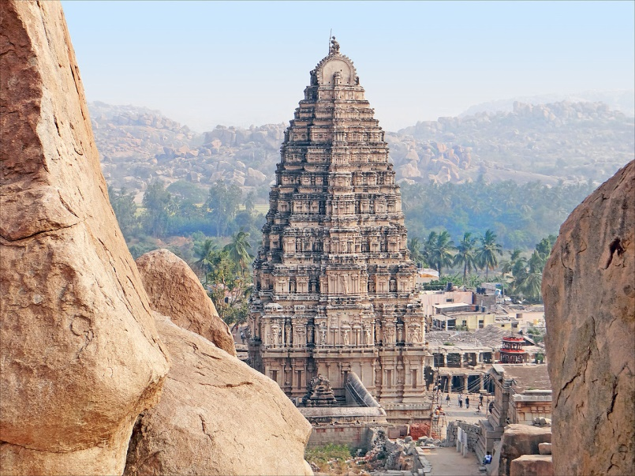 Gopuram of Virupaksha Temple

Source; Archaeological Survey of India

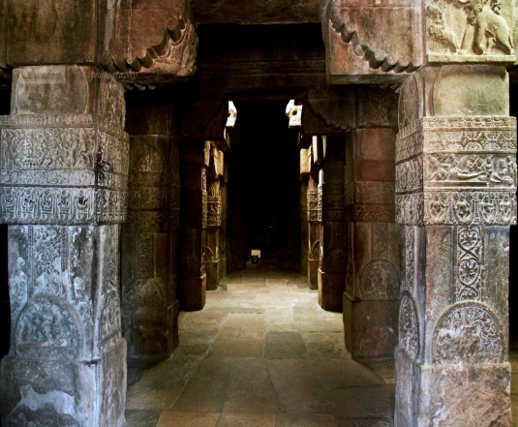` The most important part of the temple is the 18 pillars in 4 rows at the spacious mukhamandapa. They contain fine sculptures of Ramayana, Mahabharata & Bhagavata purana. There are also pictures depicting the Illusions. Poses of couples on pillars & the Series of amorous couples in various intimate poses.

Mukhamandapa inside Virupaksha temple

Source ; voyage361.com

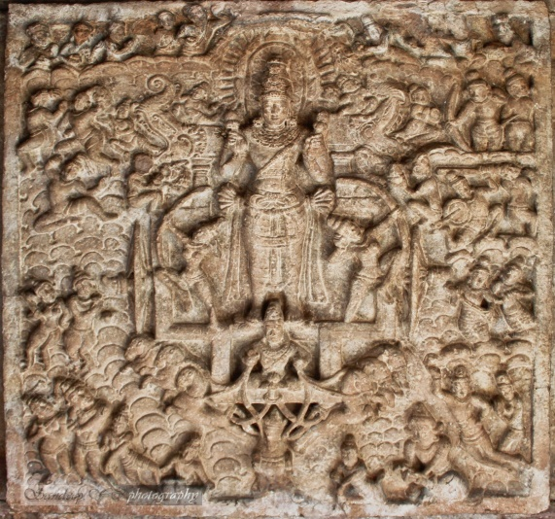At the main entrance of the Virupaksha temple from the eastern porch, the inner ceiling with huge image of Surya, the god of the sun, is driven in his chariot across the heavens in this panel from the ceiling of the temple. This rather symmetric composition includes a radiant crown for the god; makaras disgorging smaller figures at his shoulders; Aruna ("Dawn"), his legless charioteer, at the bottom of the panel, holding the reins of seven horses representing the days of the week; a plethora of other divinities; & scalloped clouds (the usual convention) on either side. The archers standing by Surya's legs personify the light of Dawn, whose arrow-like rays dispell the darkness at the break of day.

Surya deva, driven in his chariot holding the rein of 7 horses

Source ; voyage361.com

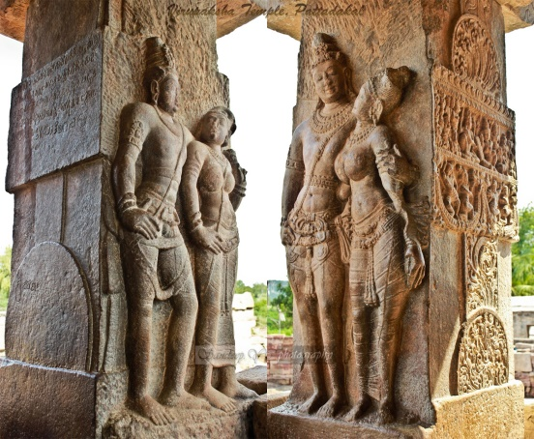

There are Guardian on both sides of the entrance, this nonchalant guardian's oversize club, as a martial art & form of exercise(shown left in the below pic). As an attribute, the club can belong to Shiva or Vishnu. Since the guardian holds aloft a snake in his right rear hand, his affiliation is undoubtedly to Shiva. Here is another guardian, with a different kind of club, in a somewhat relaxed if not quite so casual pose as his brother in the previous photo.

Guardian on both side